**Also**

**Ability to Use Income Statement (Basic)**

Calculate profit margin and know what it means

**Lecture 1**

Business Plan

Executive Summary

Components of the Plan

Define a Small Business

Reasons for Business Failure

Types of a Business

Characteristics of an Entrepreneur

**Lecture 2**

Ability to identify an opportunity (SA)

Describe traits of an entrepreneur (SA)

Elevator Pitch or Value Proposition

**Lecture 3**

Forms of a Feasibility Analysis (4)

Product, Feature, Benefit

**Lecture 4**

Four Business Types

* Sole Proprietorship
* Partnership
* Corporation
* Limited Liability
* Company

Characteristics

* Liability
* Formation Ease
* Ownership
* Taxation

**Lecture 5**

Industry and Market

How Industry Factors and Firm Factors Affect Performance

Competitor Analysis

PESTLE

Porters Five Forces

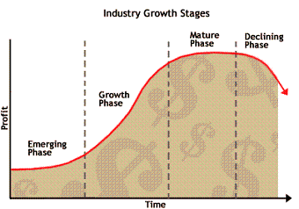

The Language of Markets

* Segment
* Industry
* Target Market
* Niche Market
* Target Customer
* Positioning

**Lecture 6**

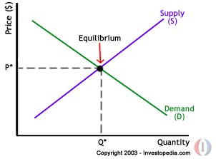

**Total Revenue**

* Your Profit it is equal to what you sell times the price of what you sell

**Net Profit**

* Is how much is left after **every** expense has been paid

Variable Costs

Fixed Costs

Break Even Analysis

Income Statement

**Lecture 7**

Financing

* Debt
* Equity
  + VC
  + Angels
* Personal Funds
  + Bootstrapping
* Creative Ways

Initial Public Offering

**Lecture 8**

4 financial objectives

Cash Accrual Methods

Sensitivity analysis- Looking at changing fixed or variable costs